COMPS203F Lab 11 File II

Instructions
- Download the lab materials from OLE and unzip it to your desktop.
- The source folder contains all the source files for each question.
- For those students who are using the PC in school labs, boot up the partition Ewin64.
- Refer to the last page for submission details. Only lab 5 and 7 will be marked finally, other labs submitted will NOT be marked.

[Part A] Example
Study the examples provided from the sample folder with the order specified below:
- Write Read File
- File Property

[Part B] Exercises
Q1 Writing and Reading Object to File
- Create a class Person with details below:
  - Add three attributes name (String), age (int) and gender (String).
  - Add a constructor method public Person(String name, int age, String gender)
  - Add a toString() method which returns a String containing a format like this:
(John,20,Male)

- Create a class TestPerson with details below:
  - Add a main method which create a new Person object (person1 - name: “John”, age: 20, gender: Male) using the Person constructor method.
  - Print out the information of the Person directly using System.out.println() by passing the object (person1) as a parameter.

  - Check the output as:
(John,20,Male)

- Create a class WRPersonObject, in the main method(), complete the following:
- Create a person object (p1 - "Rachel", 25, "Female")
Person ______ = new ______(____________);

- Write object p1 to a text file named PersonObjectFile.txt

- Read object p1 from file PersonObjectFile.txt,
- Print out the output as:
(Rachel,25,Female)

- Create an array of person objects personArrOut with elements:
("Ashley", 18, "Female")
("Brian", 45, "Male")
("Oscar", 16, "Male")

- Write object array personArrOut to PersonObjectFile.txt by simply adding one line by calling method .writeObject(). No need to open new file connection as you have already done so in part(b).

- Read object array personArrOut from PersonObjectFile.txt, simply add one line by calling method .readObject().

- Print out the Output as:
[(Ashley,18,Female), (Brian,45,Male), (Oscar,16,Male)]

Q2 Simple GUI File Manager (Homework)
- Write a class FileManager as a subclass of JFrame. It has a text field of length 20 and a button labelled "List". The final result looks like the figure on the right. The title "Simple File Manager" can be created by calling super() and passing a suitable string to it. Write the main() method so that FileManager can be run.
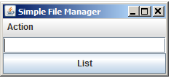

import _____________;
import _____________;
import _____________;
import _____________;
import _____________;

public class FileManager ___________________________________ {
private JTextField textField = _____________;
private JButton button = _____________;

//menu
private JMenuBar menuBar = _____________;
private JMenu actionMenu = _____________;
private JMenuItem renameItem = _____________;
private JMenuItem deleteItem = _____________;
…

public FileManager() {
//set title using super():

//set menu below:

//add Action Listeners

//set layout using BorderLayout()

setDefaultCloseOperation(EXIT_ON_CLOSE);
pack();
}
…

- Create a text file f1.txt under the same directory, the file has no content in it.

Using Window Explorer:
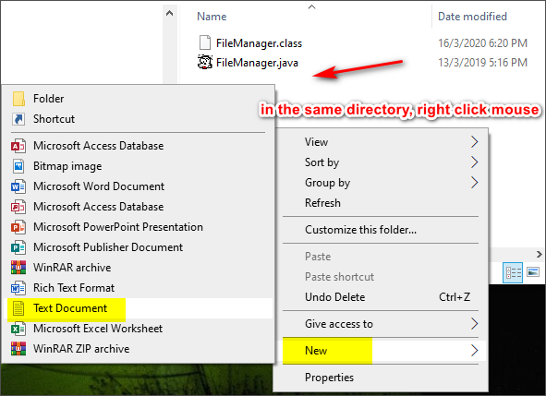

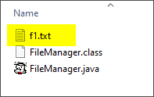

- Add the action handling statement(s) and method to the class so that when the button is pressed, the list of file names of the directory entered in the text field is displayed in a message dialog.
[Note: assume the textfield is empty when the button is pressed in which the current directory will be listed.]
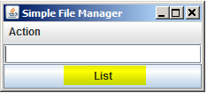
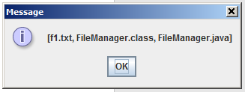

- Add a pull-down menu to the class to support the operation "Rename", which renames a file whose original name is entered into the text field. After the pull-down menu item has been selected, an input dialog box is displayed asking for the new name. You can assume the file with original name exists but the one with the new name does not. Remember to check the return value to see if the operation is successful or not.

Enter “f1.txt” only (do not click List button)
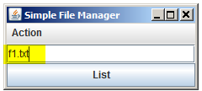

Click Rename
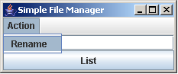

Enter “f2.txt”, then click OK button
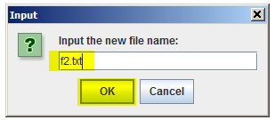

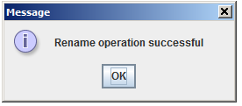

Now, check with the current directory, textfield is empty

The file is renamed successfully
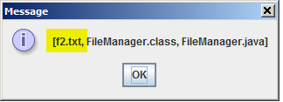

Using Window Explorer:
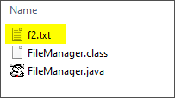

- Now add code to handle the case where the original file does not exist or the new file already exists. In each of the cases, display an error message and ask the user to input the file name again using a dialog box.

Case 1 (Empty textfield and then click “Rename” from the menu list):
Click Rename

Empty textfield
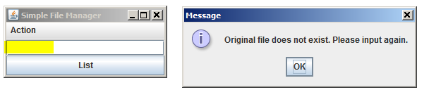

Case 2 (file name not exists i.e. enter 123.txt and then click “Rename” from the menu list): 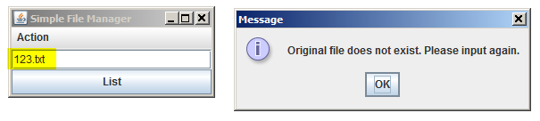

Case 3: if f1.txt exists but the new file also named f1.txt
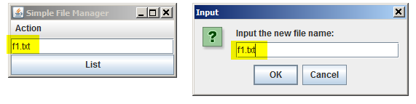
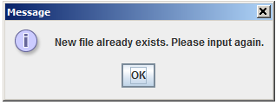

- In the pull-down menu, add a menu item "Delete" for deleting the file with its name in the text field. If the file exists, ask the user to confirm the deletion using a dialog box. Otherwise, display an error message asking the user the input the correct file name again. Remember to check the return value to see if the operation is successful or not.

Check with the current directory

Assume f2.txt exists in the current directory, create a new one if it doesn’t.

Enter f2.txt in the textfield
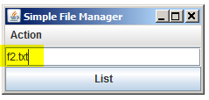
Click Delete
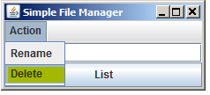

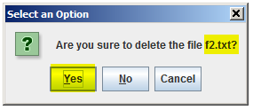
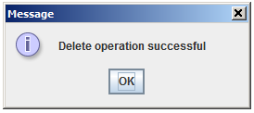

Now, check again with the current directory

File is deleted
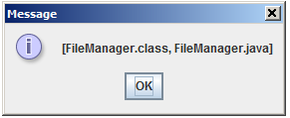

Compress the .java files from the homework question into a zip file using 8-digit of your student ID i.e. 12345678.zip, and then submit to OLE on or before the due date.

Prepared by Terri Wong

